**Lab#8 Loans MicroService**

----------------------------------------------------------------------------------------------------------------

In this lab we will create a loans microservice, similar to the accounts service.

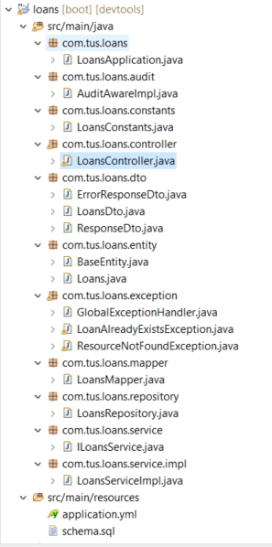

**Figure 1: Project Layout**

Schema.sql, LoansConstants, ILoansService and LoansServiceImpl and LoansMapper files are given. Use port 8090 in the .yml file.

**Creating a Loan**

First create a customer as before using the accounts microservice.

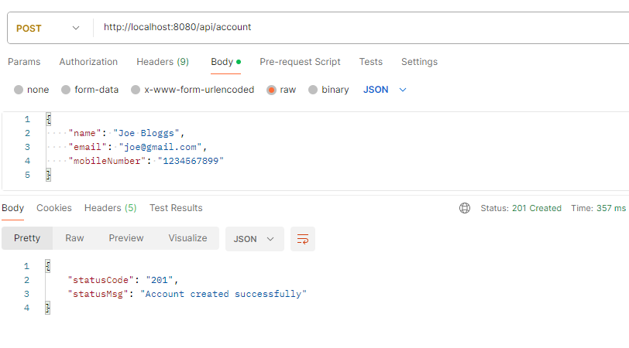

**Fig. 2 Create a customer**

Now using the same mobile number create a loan. The mobile number supplied must be 10 digits long. A loan cannot already exist for the customer with given mobile number.

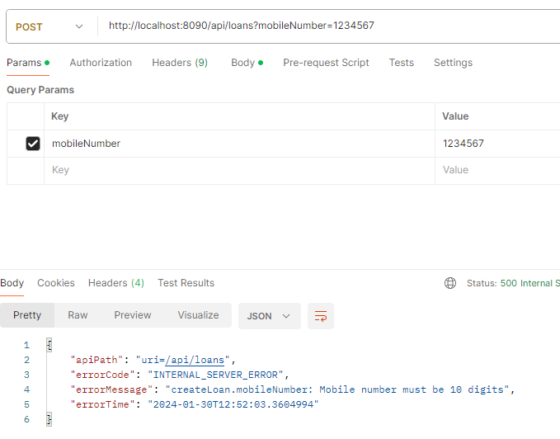

**Fig. 3 Create a loan - Mobile number too short**

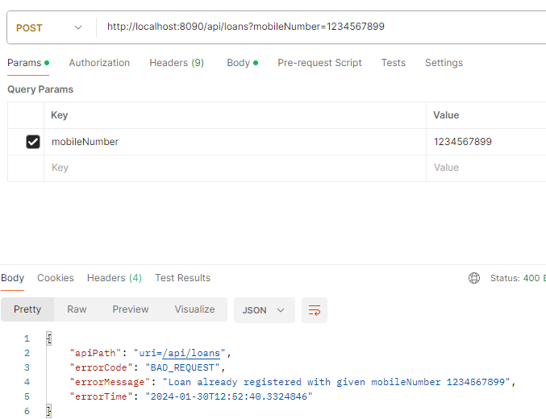

**Fig. 4 Create a loan - Loan already exists for customer**

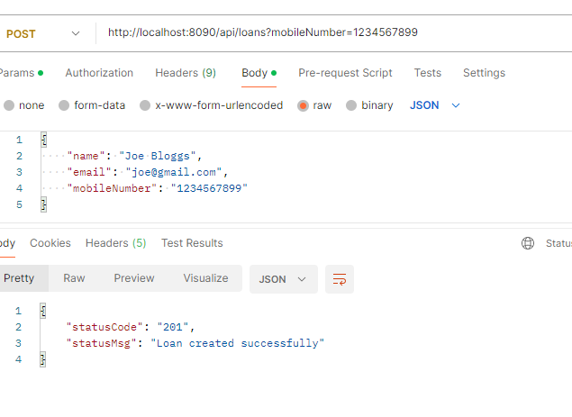

**Fig. 5 Loan created success.**

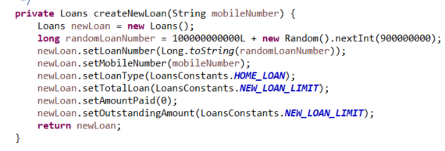

**Fig. 6 Creating a loan – code in LoansServiceImpl**

The loan is create using default values as shown and the number is generated as shown

**Fetch loan details**

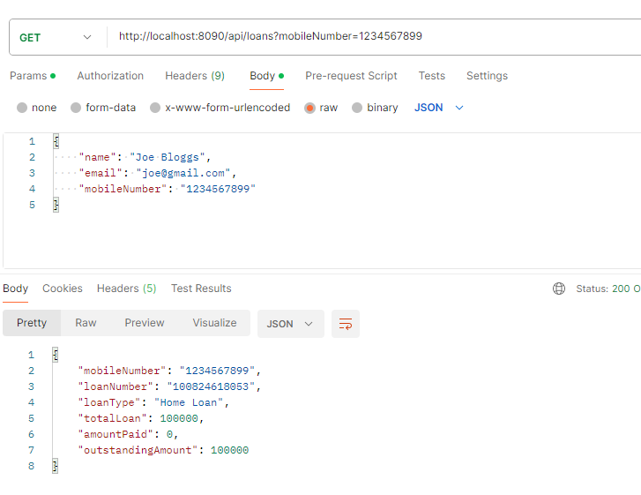

**Fig. 7 Fetching loan details - success**

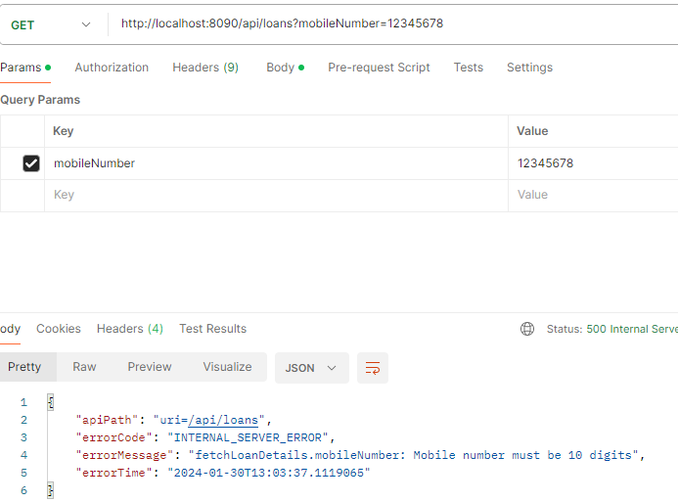

**Fig. 8 Fetching loan - mobile number not 10 digits**

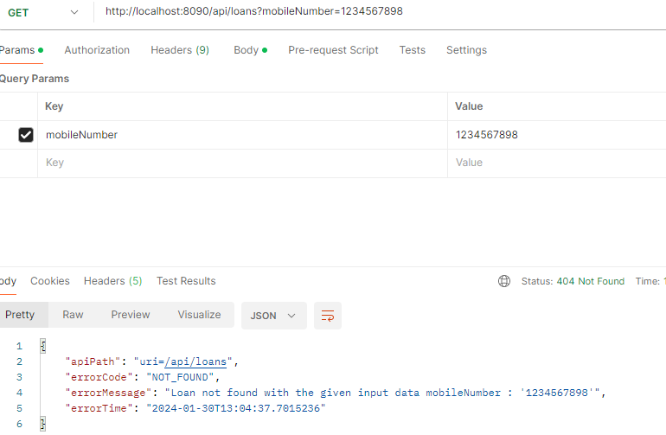

**Fig. 9 Fetching loan – no loan for given mobile number**

**Update Loan details**

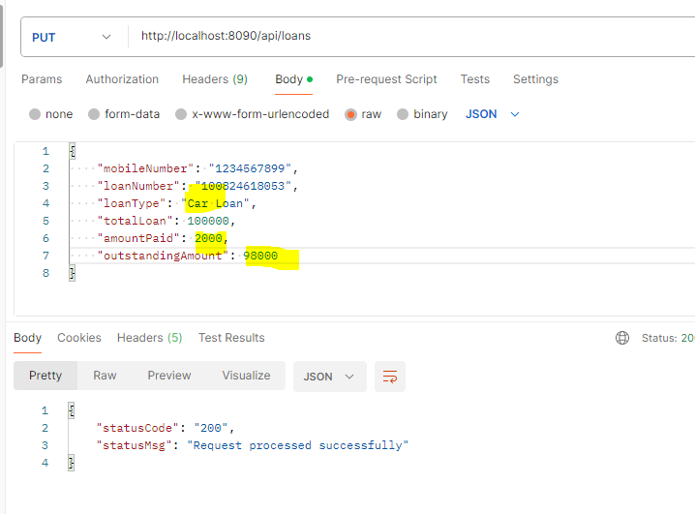

**Fig. 10 Updating loan –loan details updated successfully**

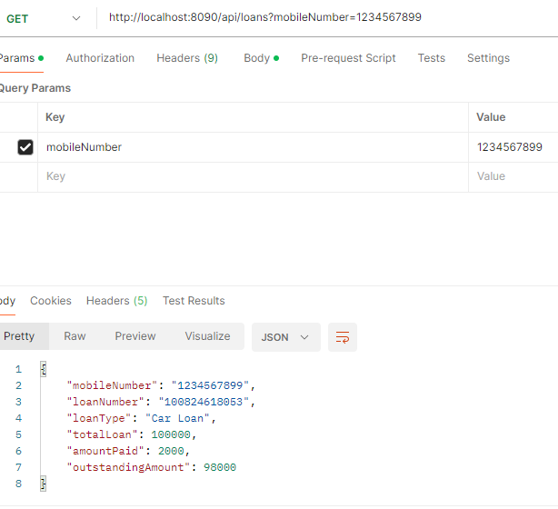

**Fig. 11 Fetch updated values –loan details updated**

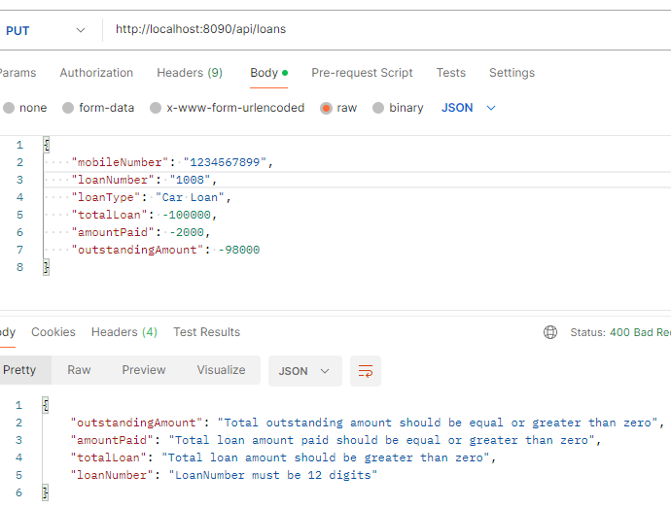

**Fig. 12 Updating loan –validation errors in data**

See LoansDto for error example

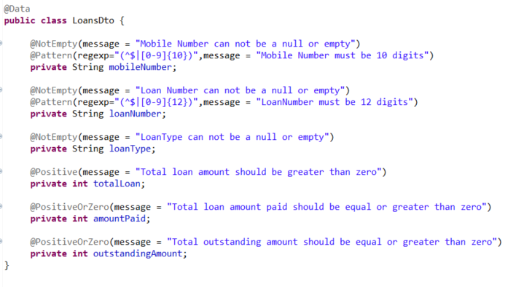

**Fig. 13 Handling errors in LoansDto**

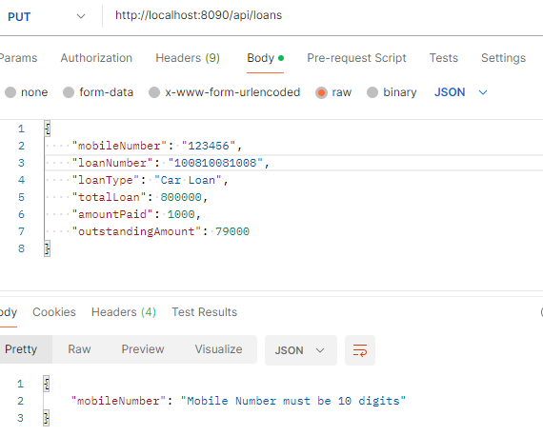

**Fig. 14 Update loan - Mobile number not 10 digits**

**DELETE Mapping**

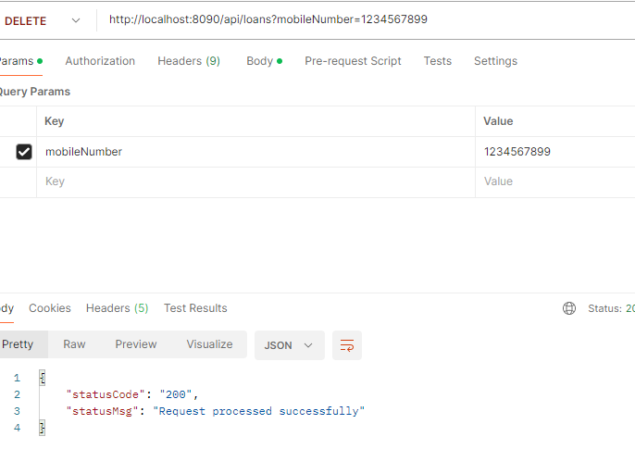

**Fig. 15 Deleting a loan**

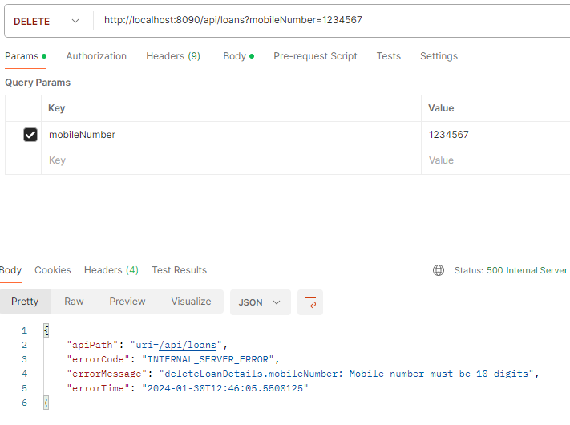

**Fig. 16 Deleting a loan – mobile number too short**

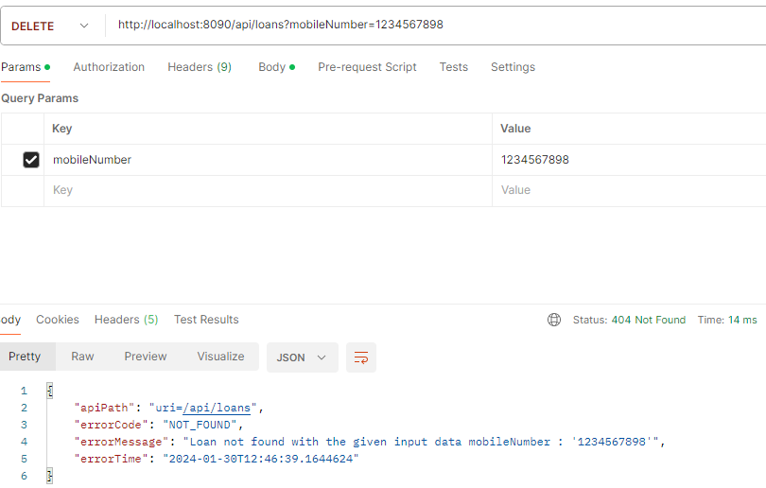

**Fig. 17 Deleting a loan – loan with mobile number not found**